Experiment 9
Name: Padma Priya D Roll No: 240701377
Design input forms that validate data (email, phone number) and display error messages using HTML, CSS, and JavaScript.

AIM
To design an input form that validates user data such as email and phone number and displays appropriate error messages using HTML, CSS, and JavaScript with Validator.js.
OBJECTIVE
- To create a user-friendly form
- To validate user input in real-time
- To display error and success messages
- To improve form usability
TOOLS USED
- HTML
- CSS
- JavaScript
- Validator.js (Library)

THEORY
Form validation ensures that user input is correct before submitting the form.
- HTML is used to create the structure
- CSS is used for styling
- JavaScript is used for validation logic
- Validator.js helps validate email and phone formats
Validation improves:
✔ Data accuracy
✔ User experience
✔ Security

PROCEDURE

🔹 Step 1: Creating HTML Form

Explanation
An HTML form is created with:
- Email input field
- Phone number input field
- Error message display area
- Submit button
Code (HTML)
<!DOCTYPE html>
<html lang="en">
<head>
<meta charset="UTF-8">
<meta name="viewport" content="width=device-width, initial-scale=1.0">
<title>Form Validation Experiment</title>
<link rel="stylesheet" href="style.css">
<script src="https://cdnjs.cloudflare.com/ajax/libs/validator/13.9.0/validator.min.js"></script>
</head>
<body>
<div class="container">
<h2>Contact Information</h2>
<form id="contactForm">
<div class="form-group">
<label for="email">Email Address</label>
<input type="email" id="email" name="email" placeholder="Enter your email">
<div class="error-message" id="emailError"></div>
</div>

<div class="form-group">
<label for="phone">Phone Number</label>
<input type="tel" id="phone" name="phone" placeholder="Enter your phone number">
<div class="error-message" id="phoneError"></div>
</div>

<button type="submit">Submit</button>
</form>
<div id="successMessage" class="success-message hidden">Form submitted successfully!</div>
</div>
<script src="script.js"></script>
</body>
</html>

Output Screen (Step 1)

A simple form with:
- Email field
- Phone field
- Submit button
(No validation yet)
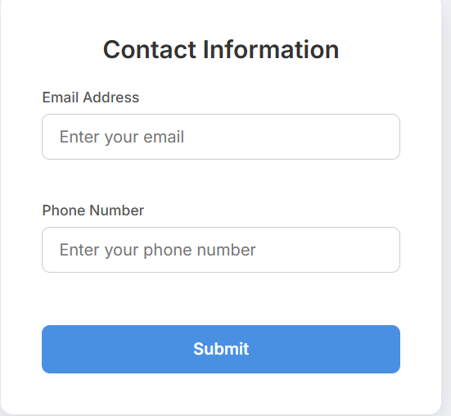

🔹 Step 2: Styling with CSS

Explanation
CSS is used to:
- Center the form
- Add colors and spacing
- Highlight input fields
- Show error styles

Features Added
- Rounded input boxes
- Button hover effect
- Error highlight (red border)
- Clean UI design

Code (CSS)
@import url('https://fonts.googleapis.com/css2?family=Inter:wght@400;500;600&display=swap');

body {
font-family: 'Inter', sans-serif;
background-color: #f0f2f5;
display: flex;
justify-content: center;
align-items: center;
height: 100vh;
margin: 0;
}

.container {
background-color: #ffffff;
padding: 40px;
border-radius: 12px;
box-shadow: 0 8px 24px rgba(0, 0, 0, 0.1);
width: 100%;
max-width: 350px;
transition: transform 0.3s ease;
}

.container:hover {
transform: translateY(-5px);
}

h2 {
color: #333;
margin-top: 0;
margin-bottom: 24px;
text-align: center;
font-weight: 600;
}

.form-group {
margin-bottom: 20px;
}

label {
display: block;
margin-bottom: 8px;
color: #555;
font-weight: 500;
font-size: 14px;
}

input {
width: 100%;
padding: 12px 16px;
border: 1px solid #ccc;
border-radius: 8px;
font-size: 16px;
box-sizing: border-box;
transition: border-color 0.3s ease, box-shadow 0.3s ease;
font-family: 'Inter', sans-serif;
}

input:focus {
outline: none;
border-color: #4a90e2;
box-shadow: 0 0 0 3px rgba(74, 144, 226, 0.2);
}

input.error {
border-color: #e74c3c;
box-shadow: 0 0 0 3px rgba(231, 76, 60, 0.2);
}

.error-message {
color: #e74c3c;
font-size: 12px;
margin-top: 6px;
min-height: 15px;
font-weight: 500;
}

button {
width: 100%;
padding: 14px;
background-color: #4a90e2;
color: white;
border: none;
border-radius: 8px;
font-size: 16px;
font-weight: 600;
cursor: pointer;
transition: background-color 0.3s ease, transform 0.1s ease;
font-family: 'Inter', sans-serif;
margin-top: 10px;
}

button:hover {
background-color: #357abd;
}

button:active {
transform: scale(0.98);
}

.success-message {
margin-top: 20px;
padding: 12px;
background-color: #d4edda;
color: #155724;
border: 1px solid #c3e6cb;
border-radius: 8px;
text-align: center;
font-weight: 500;
}

.hidden {
display: none;
}

Output Screen (Step 2)

Styled form:
- Centered layout
- Blue button
- Clean design

Step 3: JavaScript Validation

Explanation
JavaScript is used to:
- Validate email using validator.isEmail()
- Validate phone using validator.isMobilePhone()
- Show error messages
- Show success message

Validation Types
Real-time validation (while typing)
Submit validation
Code (JavaScript)
document.addEventListener('DOMContentLoaded', () => {
const form = document.getElementById('contactForm');
const emailInput = document.getElementById('email');
const phoneInput = document.getElementById('phone');
const emailError = document.getElementById('emailError');
const phoneError = document.getElementById('phoneError');
const successMessage = document.getElementById('successMessage');

// Function to show error
const showError = (input, errorElement, message) => {
input.classList.add('error');
errorElement.textContent = message;
};

// Function to clear error
const clearError = (input, errorElement) => {
input.classList.remove('error');
errorElement.textContent = '';
};

// Real-time validation for email
emailInput.addEventListener('input', () => {
if (emailInput.value.trim() === '') {
clearError(emailInput, emailError);
} else if (!validator.isEmail(emailInput.value)) {
showError(emailInput, emailError, 'Please enter a valid email address.');
} else {
clearError(emailInput, emailError);
}
});

// Real-time validation for phone
phoneInput.addEventListener('input', () => {
const phoneVal = phoneInput.value.trim();
if (phoneVal === '') {
clearError(phoneInput, phoneError);
} else if (!validator.isMobilePhone(phoneVal, 'any')) {
showError(phoneInput, phoneError, 'Please enter a valid phone number.');
} else {
clearError(phoneInput, phoneError);
}
});

// Form submission validation
form.addEventListener('submit', (e) => {
e.preventDefault();

let isValid = true;
const emailVal = emailInput.value.trim();
const phoneVal = phoneInput.value.trim();

// Validate Email
if (emailVal === '') {
showError(emailInput, emailError, 'Email is required.');
isValid = false;
} else if (!validator.isEmail(emailVal)) {
showError(emailInput, emailError, 'Please enter a valid email address.');
isValid = false;
}

// Validate Phone
if (phoneVal === '') {
showError(phoneInput, phoneError, 'Phone number is required.');
isValid = false;
} else if (!validator.isMobilePhone(phoneVal, 'any')) {
showError(phoneInput, phoneError, 'Please enter a valid phone number format.');
isValid = false;
}

// Output success message
if (isValid) {
successMessage.classList.remove('hidden');
form.reset();

setTimeout(() => {
successMessage.classList.add('hidden');
}, 3000);
} else {
successMessage.classList.add('hidden');
}
});
});

Output Screens (Step 3)

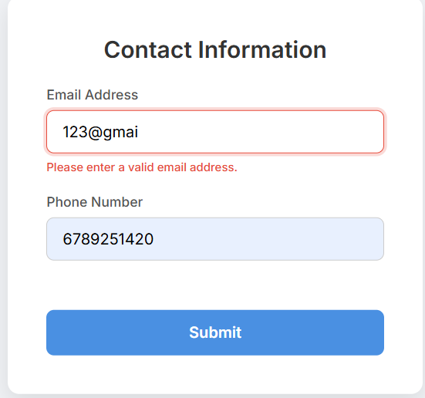
Case 1: Invalid Email
Shows: "Please enter a valid email address"
Case 2: Invalid Phone
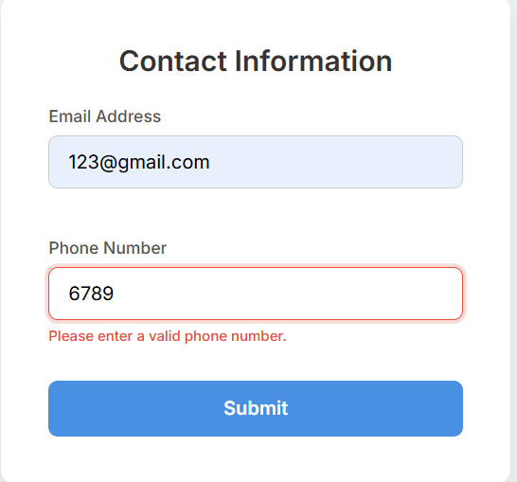
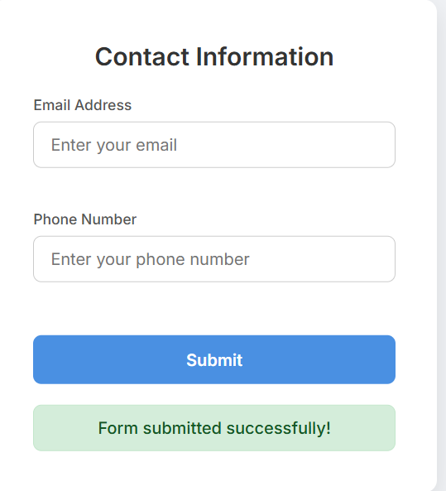
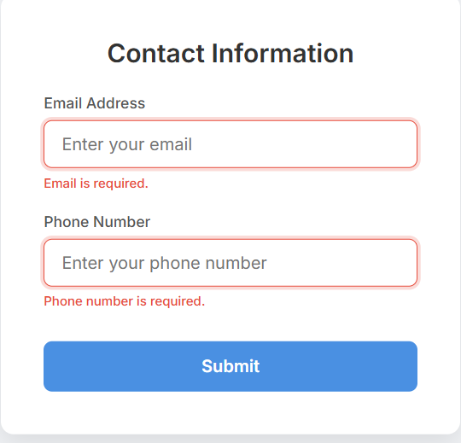
Shows: "Please enter a valid phone number"
Case 3: Empty Fields
Shows:
Email is Required
Phone number is required
Case 4: Valid Input
Shows:
Form submitted successfully

